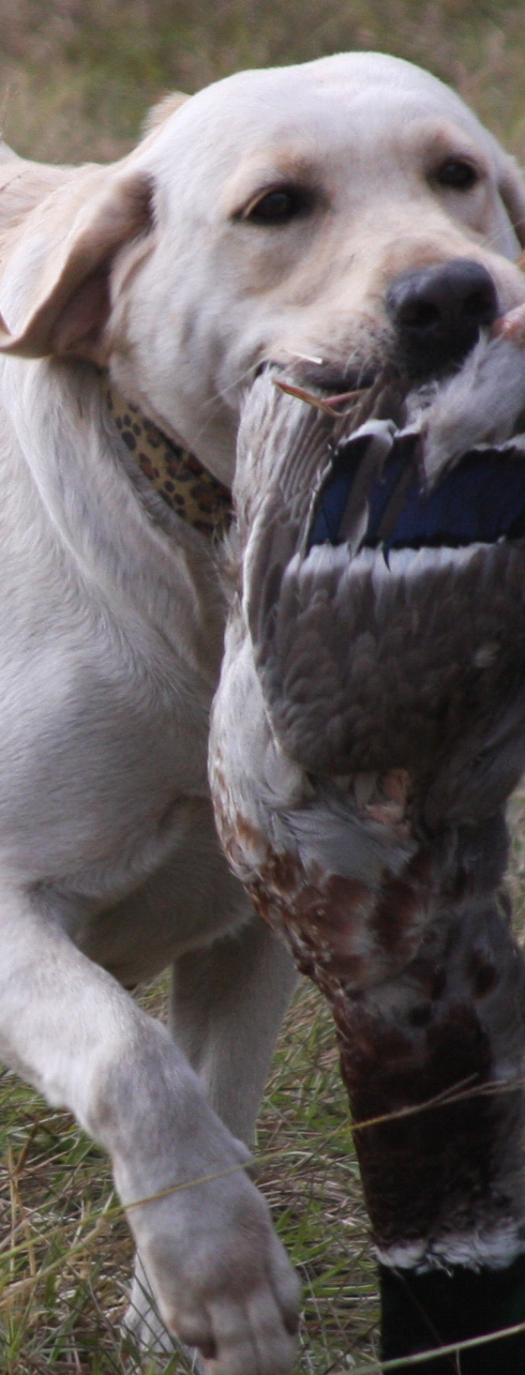
Dixie's Sergeant Chipper
SN26397004
OFA36G
Derbes
Daytona Charm
SN42638005
Osborne's
Cloe
SR09892302
OFA31E
OFEL31N
Dizzy Darling Daisy Duke
SN18896604
Derbe
Wood Conner
SM960463
Beechcroft
Whistlin
Dixie
SM91171109
Samson
Bootrey
Perry
SF797215
Fry's Cassie Of Cocoa
SM79925101
CH
Somersett
Michelob
SE455188
OFA24G
Morgan Margaret
Fluck
SM93266805
Charlie Babbitt
Fluck
SM73647701
Addy's
Brandi
SE411975
Boozer
McGoo
Perry
SE170092
OSBORNE'S
CLOE
Yellow
Labrador
AKCSR09892302
UKC
R188
-002
OFA31
Excellent
OFEL31
Normal
Beechcrofts
Larkspur
SF721462
OFA24E
CH
Tweedledum
Pop My Cork
SM86016401
OFA26G
OFEL26

